**Assignment 7.1**

**Sales of different TV Task 4**: Write a Mapreduce program to modify Sales of different TV to use a custom partitioner with 4 reducers. Make sure that all records whose company name starts with A-F (upper or lower case) should go to 1st reducer, those starting with G-L to 2nd reducer, those starting with M-R to 3rd reducer and others to 4th reducer.

**Task Driver:**

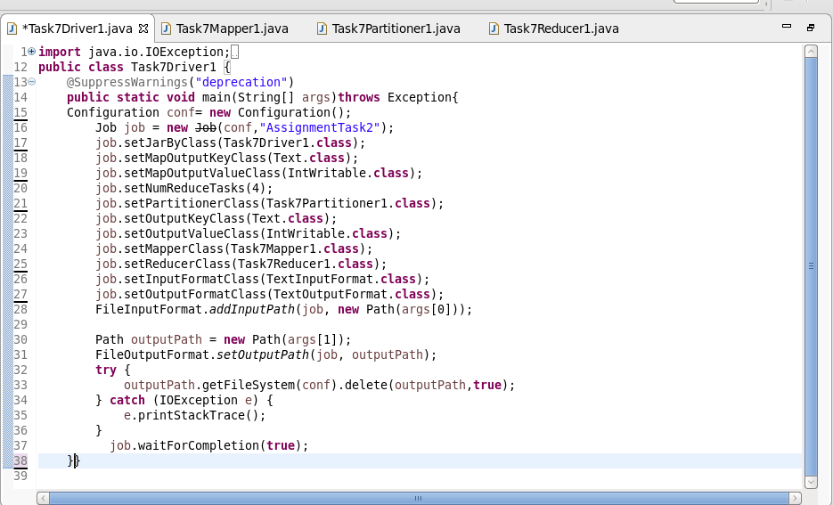

**Task Mapper:**

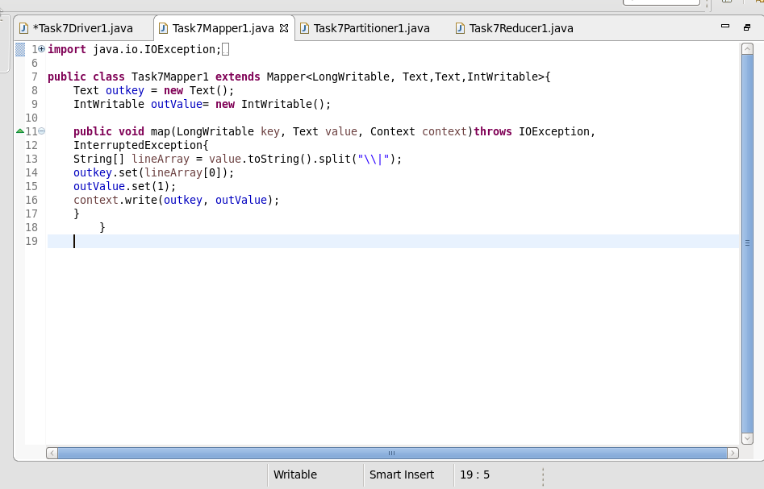

**Task Partitioner:**

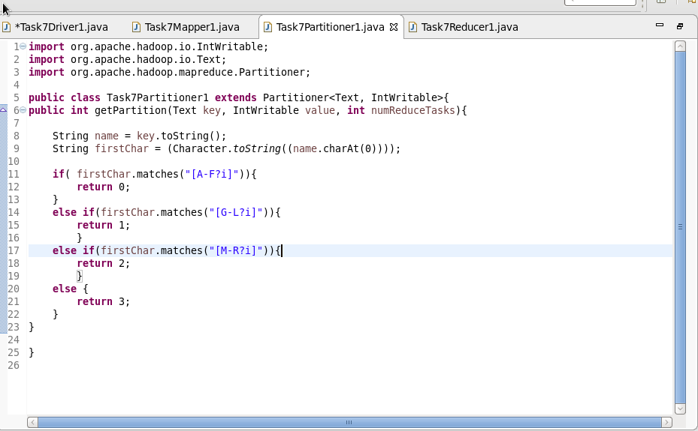

**Task Reducer:**

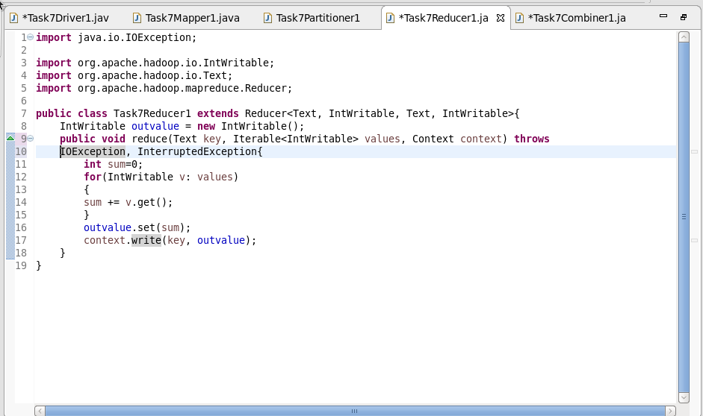

**Output:**

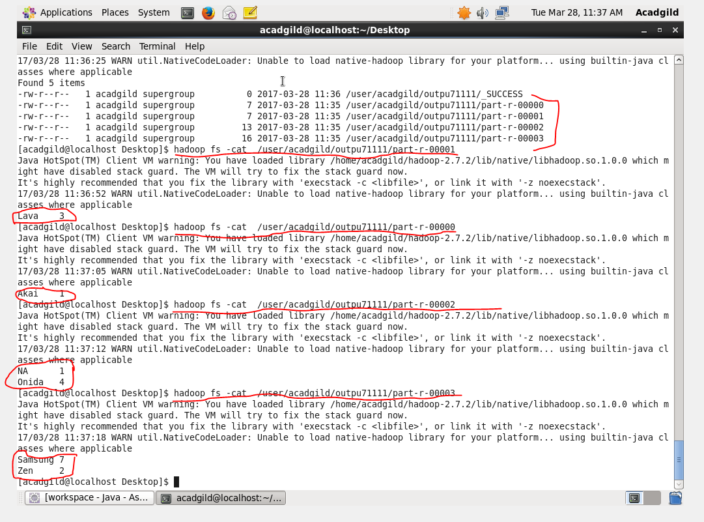

**Sales of different TV Task 5:** Modify Sales of different TV Task 2 (refer session 5, assignment 2) to take advantage of Combiner.

**Driver class:**



**Mapper Class:**



**Reducer class:**



Partitioner Class:



Combiner class:

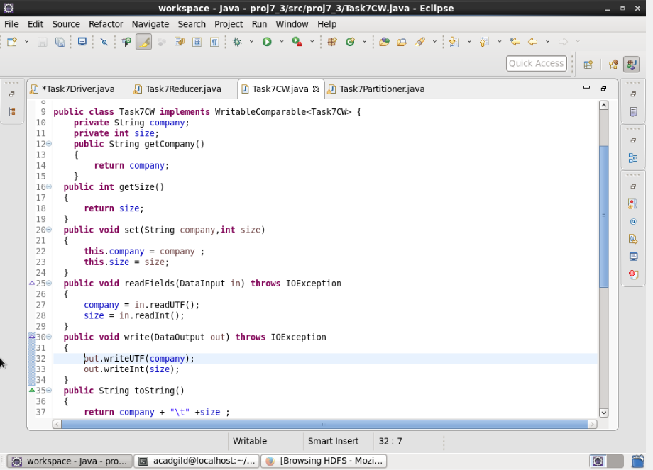

Output:

